**How to Access Cognos**

**Before you begin**: You must be either on campus and attached to the campus network, or you must be logged into the Virtual Desktop Interface in order to access the report. For instructions on logging into VDI, visit this website: https://laverne.edu/technology/virtual-desktop/

1. Log into the portal and click on Cognos Production from the Staff Resources section.

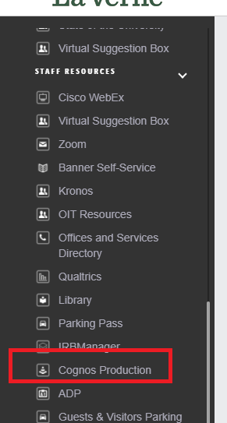

1. You should be logged into Cognos and see the landing page. Click on Team Content and then click on the Student Folder.

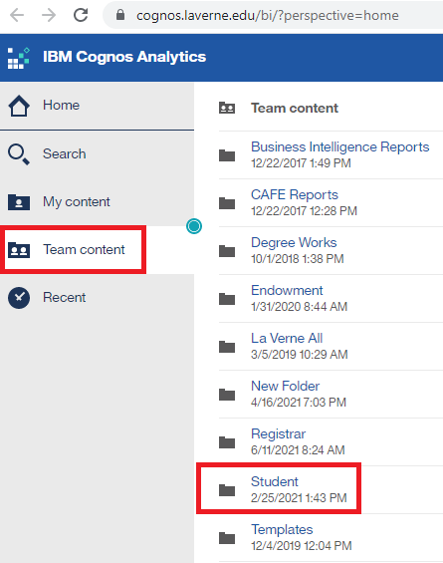

1. Click on Faculty Student Reports.

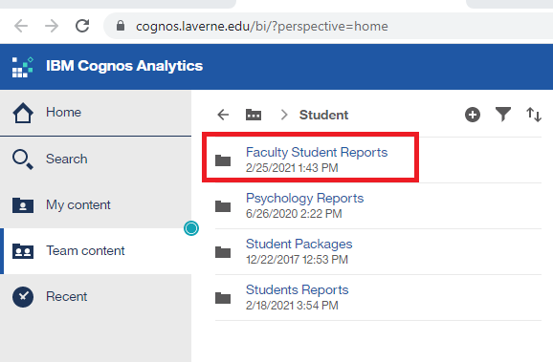

1. Click on Faculty Class Roster.

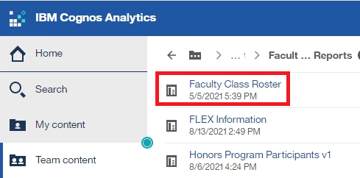

1. Instructions are listed on the left hand side of the report. Follow the steps listed.

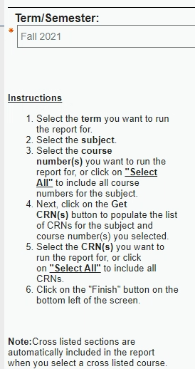

1. Click the Finish button.

To Download as an Excel Spreadsheet, click on the down arrow next to the Run Report icon.

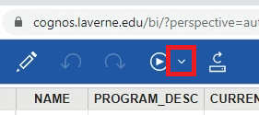

From the options, select Run Excel.

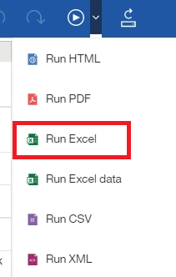

The file will run to your Downloads folder.